Supplementary Materials
Supplementary materials to accompany Efficacy classification of modern therapies in multiple sclerosis
Appendix A Baseline Risk Adjusted NMA Results

Baseline Risk Adjusted NMA Results
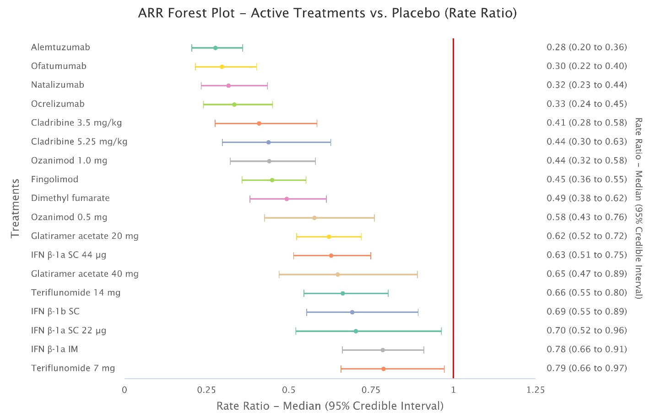Figure S1. Forest plot of DMT versus placebo effect estimates for the baseline risk adjusted ARR NMA.
ARR: annualised relapse rate; DMT: disease-modifying therapy; IFN: interferon; IM: intramuscular; NMA: network meta-analysis; SC: subcutaneous.

